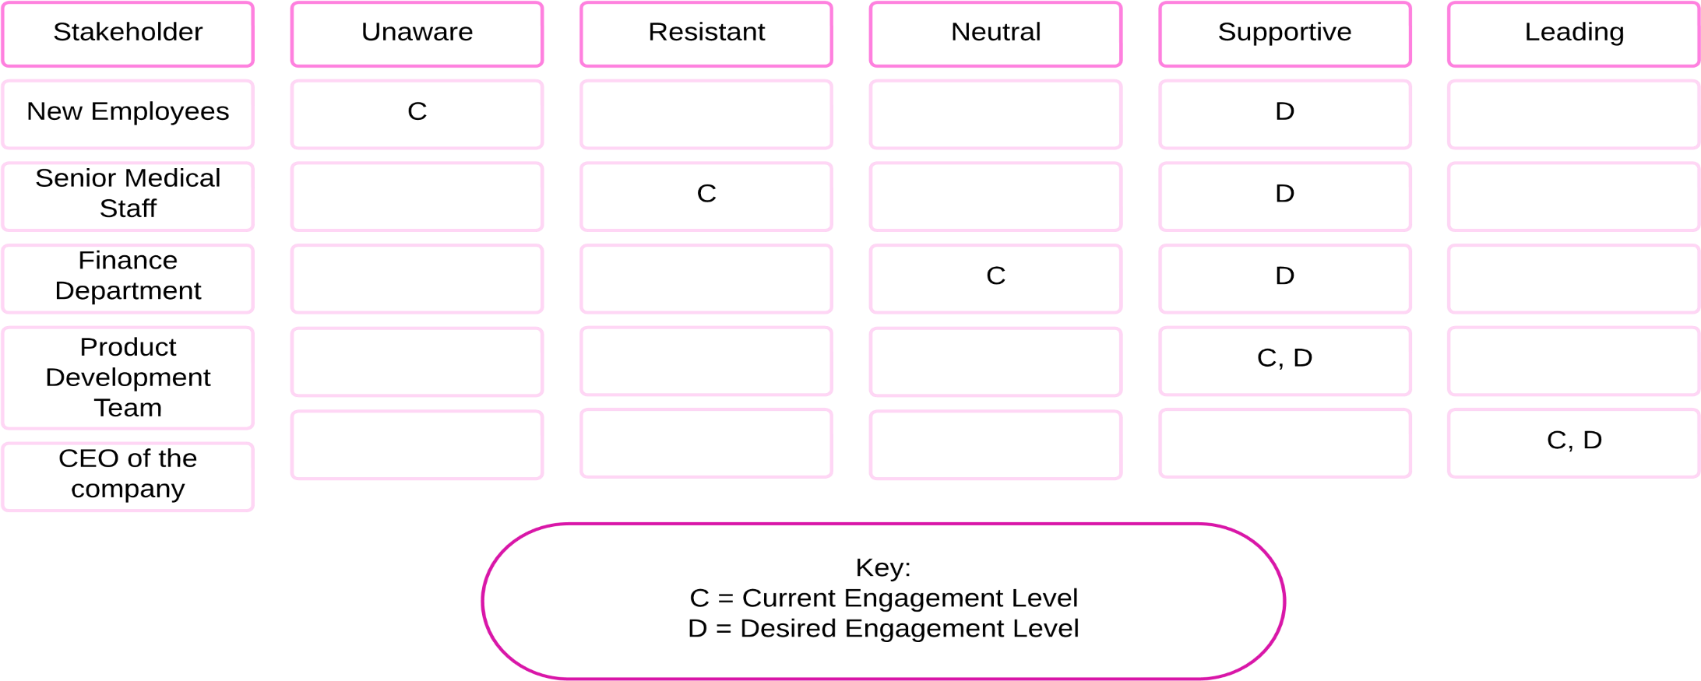

**Case Studies**

**New Employees:**

Junior employees may be unaware of the project because they are not directly involved in the development process or strategic planning meetings. To increase awareness, the company could organize internal communication sessions or workshops to inform all employees about the new technology and its potential impact.

**Senior Medical Staff:**

These stakeholders resist the new technology due to concerns about its safety, lack of long-term data, and how it fits with established medical practices. To address their resistance, the company should provide detailed safety studies, case studies from early trials, and engage them in discussions about integrating the new technology into traditional care models.

**Finance Department:**

The finance department remains neutral because they require comprehensive cost analyses and forecasts to determine the project’s financial viability. They could be persuaded to support the project through detailed cost-benefit analyses and projections showing potential returns on investment and cost savings over time.

**Research & Development Team:**

The R&D team is supportive because they are directly involved in developing the technology and believe in its potential to transform glaucoma treatment. They are enthusiastic advocates for the project, conducting experiments, refining the product, and presenting positive findings to other stakeholders.

**Executive Leadership Team:**

The project manager is a leading stakeholder because they manage day-to-day operations, coordinate cross-departmental efforts, and ensure alignment with the company’s strategic goals. They provide leadership, motivate teams, and communicate progress to the executive team.